MET CS 555 Assignment 6
Joseph Rissman
12/6/2024
- We are interested in whether the proportion of men and women with body temperatures greater than or equal to 98.6 degrees Fahrenheit are equal. Therefore, we need to dichotomize the body temperature variable. Create a new variable, called “temp_level” in which temp_level = 1 if body temperature >= 98.6 and temp_level=0 if body temperature < 98.6.
- Summarize the data relating to body temperature level (i.e., the variable you created above) by sex.
Sex | Temperature < 98.6 | Temperature >= 98.6
Male | 51 | 14
Female | 30 | 35

- Calculate the risk difference for high body temperature level between men and women. Formally test (at the $α=0.05$ level) whether the proportion of people with higher body temperatures (greater than or equal to 98.6) is the same across men and women based on this effect measure. You should be showing all 5 steps in the 5-step recipe for testing.
The estimate of the risk difference is equal to the difference of the proportions.
$$\hat{RD}={\hat{p}}_{female}-{\hat{p}}_{male}=\frac{35}{65}-\frac{14}{65}=0.538-0.215=0.323$$
- Set up the hypotheses and select the alpha level.
$H_{0}⋮p_{female}=p_{male}$ (the population proportion of people with higher body temperatures, greater than or equal to 98.6, is the same across men and women)
$H_{a}⋮p_{female}≠p_{male}$ (the population proportion of people with higher body temperatures, greater than or equal to 98.6, is different for men and women)
$$α=0.05$$
- Select the appropriate test statistic.
$$z=\frac{{\hat{p}}_{f}-{\hat{p}}_{m}}{\sqrt{\hat{p}\left(1-\hat{p}\right)\left(\frac{1}{n_{f}}+\frac{1}{n_{m}}\right)}}$$
- State the decision rule.
Decision Rule: Reject $H_{0} \text{if} \left|z\right|≥1.960$. Otherwise, do not reject $H_{0}$.
- Compute the test statistic and associated p-value.
$$z=\frac{{\hat{p}}_{f}-{\hat{p}}_{m}}{\sqrt{\hat{p}\left(1-\hat{p}\right)\left(\frac{1}{n_{f}}+\frac{1}{n_{m}}\right)}}=\frac{0.538-0.215}{\sqrt{0.377\left(1-0.377\right)\left(\frac{1}{65}+\frac{1}{65}\right)}}=\frac{0.323}{\sqrt{0.00723}}=3.80$$
- Conclusion.
Reject $H_{0}$ since $3.80≥1.960.$ We have significant evidence at the $α = 0.05$ level that $p_{f}≠p_{m} (p =0.377)$. The proportion of people with higher body temperatures was 0.323 higher in females than males. We reject the null hypothesis that the underlying population proportions are the same between men and women.

- Perform a logistic regression with sex as the only explanatory variable. Formally test (at the $α = 0.05$ level) if the odds of having a temperature greater than or equal to 98.6 is the same between males and females. Again, please show all 5 steps. Additionally, include the odds ratio for sex and the associated 95% confidence interval in your summary, and interpret the value of the odds ratio. Lastly, what is the c-statistic for this model?
- Set up the hypotheses and select the alpha level.
$H_{0}⋮β_{sex}=0 or OR=1$ (there is an association between higher body temperatures and sex)
$H_{a}⋮β_{sex}≠0 or OR≠1$ (there is not an association between higher body temperatures and sex)
$$α=0.05$$
- Select the appropriate test statistic.
$$z=\frac{{\hat{β}}_{sex}}{SE_{β_{sex}}}$$
- State the decision rule.
Decision Rule: Reject $H_{0} \text{if} \left|z\right|≥1.960$. Otherwise, do not reject $H_{0}$.
- Compute the test statistic and associated p-value.
$$z=\frac{{\hat{β}}_{sex}}{SE_{β_{sex}}}=\frac{1.4469}{0.3911}=3.700$$
- Conclusion.
Reject $H_{0}$ since $3.700≥1.960.$ We have significant evidence at the $α = 0.05$ level that $β_{sex}≠0$. There is evidence of an association between sex and higher body temperature.
The odds ratio for an increased body temperature is $e^{{\hat{β}}_{sex}}=e^{1.4469}=4.25$for women compared to men.
The 95% confidence interval is $e^{{\hat{β}}_{sex}±z_{\frac{α}{2}}×SE_{β_{sex}}}=e^{1.4469±1.96×0.3911}=\left(1.9747,9.1469\right).$ We are 95% confident the true odds ratio is between 1.9747 and 9.1469. We are 95% confident that women are between 1.9747 and 9l.1469 times more likely than men to have a high body temperature.
The c-statistic for this model is 0.672.

- Perform multiple logistic regression predicting body temperature level from sex and heart rate. Briefly summarize the output from this model (no need to go through all 5 steps). Give the odds ratio for sex. Also, report the odds ratio for heart rate (for a 10-beat increase). What is the c-statistic of this model?
Coefficients: | Estimate | Std. Error | z value | Pr(>|z|)
(Intercept) | -7.34755 | 2.21406 | -3.319 | 0.000905
Sex | 1.38919 | 0.39868 | 3.484 | 0.000493
Heart rate | 0.06337 | 0.02850 | 2.223 | 0.026195
At the $α=0.05$ level, there is sufficient evidence of an association between high body temperature and sex, there is also sufficient evidence of an association between high body temperature and heart rate.
The odds ratio for sex is $e^{{\hat{β}}_{sex}}=e^{1.38919}=4.011585$.
The odds ratio for a 10-beat increase in heart rate is $e^{{\hat{β}}_{hr}×10}=e^{0.6337}=1.884521$.
The c-statistic for this model is 0.7289.
- Which model fit the data better? Support your response with evidence from your output. Present the ROC curve for the model you choose.
The multiple logistic regression model fit the data better. Larger c-statistics values indicate a better fit. The multiple logistic regression had a c-statistic of 0.7289 while the simple logistic regression had a c-statistic of 0.672. The ROC for the multiple logistic regression is:
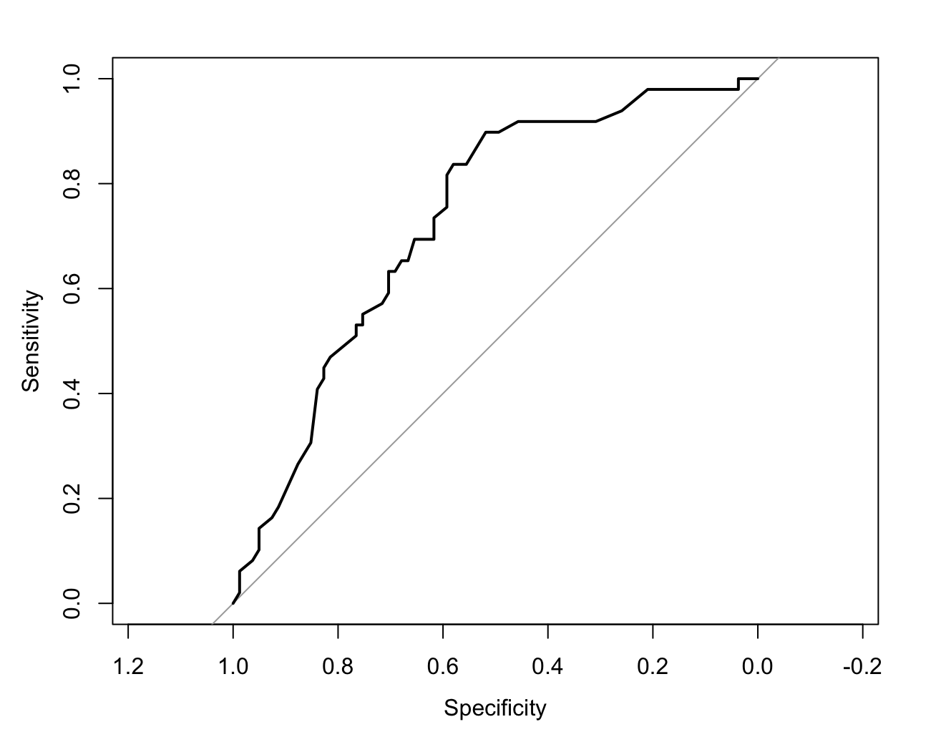

R code for Assignment 6
# CS555 Homework Assignment 6
# Load necessary libraries ------------------------------------------------

library(readxl)
library(dplyr)
library(tidyr)
library(pROC)

# Import and clean data ---------------------------------------------------

data = read_excel("Homework 6/Homework 6 Data.xlsx", col_names = TRUE)

# Problem 1 ---------------------------------------------------------------
# Create a new variable, called “temp_level” in which temp_level = 1 if body temperature >= 98.6 and temp_level=0 if body temperature < 98.6.
data$temp_level = if_else(data$temp >= 98.6, 1, 0)
summary(data)

# Problem 2 ---------------------------------------------------------------
# Summarize the data relating to body temperature level by sex.
count(data, sex, temp_level)

# Problem 3 ---------------------------------------------------------------
high_temp = data %>% filter(temp_level == 1) %>% count(sex)
measurements = data %>% count(sex)
prop.test(high_temp$n, measurements$n, correct = FALSE)

# Problem 4 ---------------------------------------------------------------
# Perform a logistic regression with sex as the only explanatory variable.
logistic = glm(temp_level ~ sex, family = binomial, data)
summary(logistic)

# Calculate the odds ratio for sex and the associated 95% confidence interval.
or = exp(logistic$coefficients["sex"])
lower95 = exp(logistic$coefficients["sex"] - qnorm(0.975) * summary(logistic)$coefficients["sex","Std. Error"])
upper95 = exp(logistic$coefficients["sex"] + qnorm(0.975) * summary(logistic)$coefficients["sex","Std. Error"])
paste0("95% confidence interval (",lower95,",",upper95,")")

# Calculate the c-statistic.
data$prob = predict(logistic, type=c("response"))
curve = roc(data$temp_level, data$prob)
print(curve)
plot(curve)

# Problem 5 ---------------------------------------------------------------
# Perform multiple logistic regression predicting body temperature level from sex and heart rate.
multiple = glm(temp_level ~ sex + `Heart rate`, family = binomial, data)
summary(multiple)

# Calculate the odds ratio for sex and heart rate (for a 10-beat increase).
or_sex = exp(multiple$coefficients["sex"])
or_hr = exp(multiple$coefficients[3] * 10)

# Calculate the c-statistic.
data$prob = predict(multiple, type=c("response"))
curve = roc(data$temp_level, data$prob)
print(curve)
plot(curve)

